Lab 2

ECE 3300 LAB

SECTION 02

Instructor: Mohamed Aly

September 20, 2021

Group I

|  |  |  |
| --- | --- | --- |
| Name | Bronco ID | Email |
| Jose Soto-Covarrubias | 013778700 | jls1@cpp.edu |
| Shreyas Surana | 013790140 | ssurana@cpp.edu |

**Abstract**

Purpose of the experiment was to create a simple adder/subtractor using all the switches on the Arty 7 FPGA board. Task was to create two 16-bit inputs with three buttons. One button would be used to load in the bits for input A. The second button was used to add the bits inserted from input A and input B. The last button was to reset the board in order to use inputs A and B. Full adder was created using structural modeling then instantiated into 16 bit full adder. From there, adder subtractor was created to add between two inputs. A register was also created to store values from inputs.

**Theory: Sketch of Design**

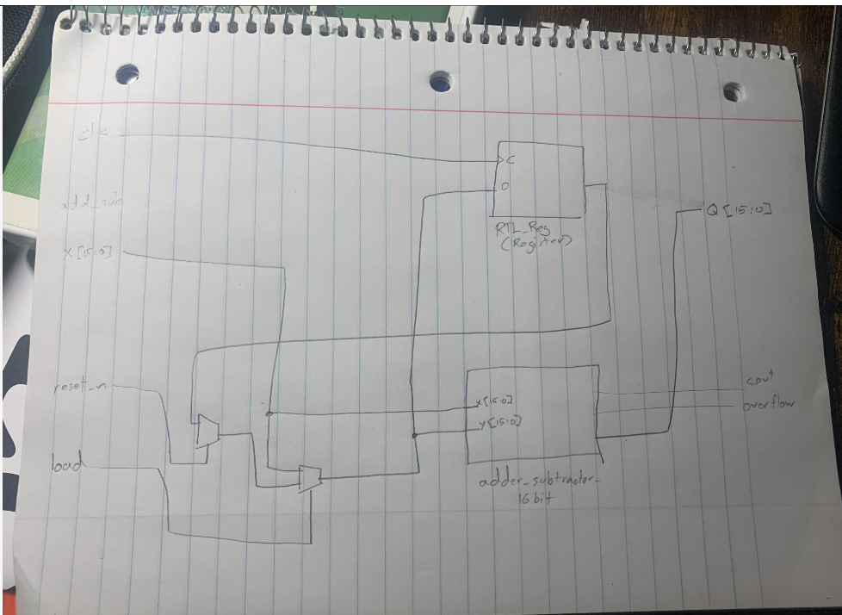

**Area/Resources Information**

Elaborated Design

**Power Usage**

**Post-Implementation Resource Utilization**

